**Brooklyn torah gazette**

**For chanukah 5783**

Vol. 7, Issue 14 (Whole Number 321) 25 Kislev – 2 Teves 5783/ Dec, 19-26, 2022

**Printed L’illuy nishmas Nechama bas R’ Noach, a”h**

For a free subscription, please forward your request to [***keren18@juno.com***](mailto:keren18@juno.com)

Past stories can be found on the website **ShabbosStories.com**

**A World War II Chanukah Night in England**

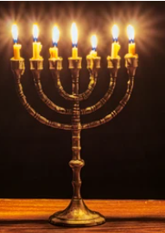

In England, during World War II, many children were evacuated from the larger cities and were sent to the countryside to escape the almost constant bombardment by the Germans. A group of Jewish children were housed in a Shul complex that had only recently been built. Next door to the main Shul building was a smaller, older, two-story building.

On Chanukah, the boys of the Cheder had a party in the Shul. They were just about to light the Menorah when suddenly the air raid siren went off. Automatically, they formed a line and went across the courtyard into the study hall, where another flight of steps led down into the bomb shelter.

**The Bombs Were Falling All Around Them**

This time, the explosions sounded unusually close to them. They could hear bombs falling all around them. After making a quick headcount, the Rebbi said, "And now, we will light the Menorah and continue our party."

It was then that they realized that in all the commotion, the Menorah had been left behind in the main Shul. They were terribly upset about this, but what could they do? The Rebbi said that Hashem would accept their good intentions and consider it as if they had fulfilled the Mitzvah anyway.

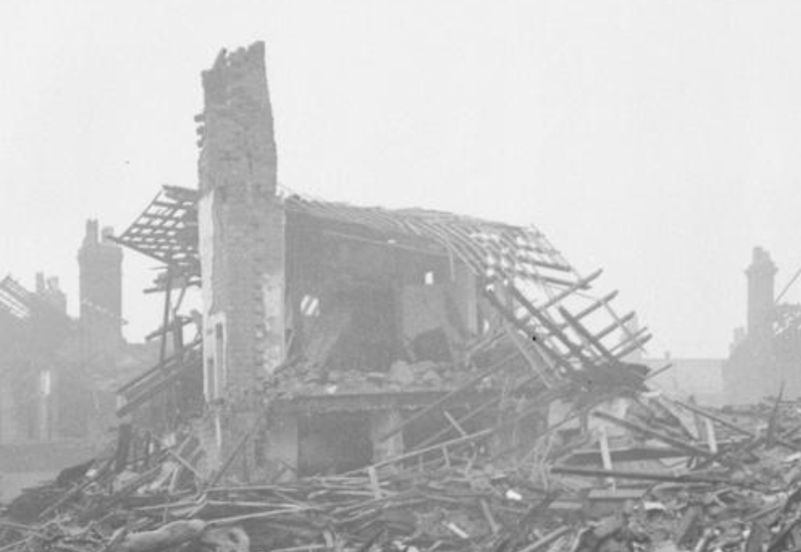

**Result of a home in England bombed by the Germans during World War II**

One boy, however, could not accept this. He really wanted to light the Menorah! He decided to sneak out of the shelter, and quickly go across the courtyard to retrieve the Menorah and candles. He couldn't ask for permission, because the Rebbi would surely forbid him to risk his life, but he reminded himself of the words of Chazal, that one who is on a mission to perform a Mitzvah is not harmed, and he slipped outside when no one was looking.

**A Most Terrifying Experience**

The whole sky was lit up by searchlights. It was terrifying. Running as fast as he could, he made it to the Shul and grabbed the Menorah and candles. However, as soon as he opened the door, a bomb hit the building next door!

His earlier burst of courage had disappeared. Trembling, he forced his legs to run across the courtyard like a bolt of lightning, only to see a firebomb land on the roof of the Shul! Now, he stood frozen in place. Should he wait for a civil defense guard to notice the fire, or should he try to do something himself? Maybe they were too busy putting out fires elsewhere.

What about his Rebbi? Was he looking for him at that very moment? In the meantime, the Shul could burn down. The courageous boy knew what to do. Fortifying himself, he hurriedly ran forward and followed the fire protocol, as they had all been subjected to repeated fire drills. There was no time to lose. He placed the Menorah and candles on the ground and grabbed a ladder that had been prepared for just such an emergency.

**Spraying Water on and Around the Fire**

Within seconds, he was on the roof of the Shul. On every roof was a huge bucket of water with a foot pump and a hose. He put the hose in the bucket and started to pump with all his might, spraying water on and around the fire. He kept on spraying until the flames had died down. The danger was averted.

Not wanting to risk getting in further trouble, and, noticing a civil defense guard battling a fire on a nearby roof, he hastily climbed down the ladder and sprinted away. Bursting into the bomb shelter triumphantly carrying the Menorah, the young boy lit the candles that night in a manner similar to the Kohein Gadol in the Bais HaMikdosh! It was truly a night to remember!

*Reprinted from the Chanukah 5781 email of Rabbi Yehuda Winzelberg’s Torah U’Tefiah.*

**Rav Elyashiv’s Two “Special” Hours After Lighting the Chanukah Menorah**

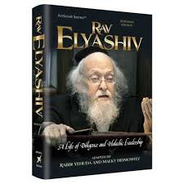

Rav Dovid Hoffman writes that the Gemara in Shabbos states (21a), “Mai Chanukah? D’Tanu Rabanan”, which means, “What is Chanukah? As our Rabbis have learned....” In other words, what is the main point of Chanukah? What is Chanukah all about? What is its purpose?

The answer is, to learn Torah, to listen to our Rabbi’s teachings, and to reinforce Limud HaTorah! Rav Yosef Shalom Elyashiv, zt”l, had a special two-hour learning seder during Chanukah which began immediately after lighting the candles and lasted until it was time for his Shiur in Yeshivas Tiferes Bachurim.

This Seder was also one of his “Chizuk Sedarim”, similar to his special learning sessions on Friday and Motzaei Shabbos. During those reserved hours, the Rav learned Torah with unmatched excitement, singing a distinctive tune and fully absorbed in the Sugya to the exclusion of everything else. During those two hours, the entire world, except for his Gemara, ceased to exist.

Rav Elyashiv’s schedule was a sight to behold, and many, many people would come from all over to witness it. Outside of his small home on Rechov Chanan, pandemonium reigned as people crowded into the narrow alley to catch a glimpse of the Gadol HaDor performing the Mitzvah of Ner Chanukah.

Half-an-hour before sunset, the entire alleyway would be packed with eager spectators, but the Rav remained totally oblivious to the turmoil outside his window, immersed as he was in his Gemara. Every single moment was precisely calculated according to the will of Hashem, and when the time for lighting the Menorah arrived, he closed his Gemara and rose to perform the Mitzvah.

Opening an old, wornout Siddur, he recited the special Tefilah before lighting, walked over to his Menorah, recited the Brachos and lit the candles, as the massive crowd below watched his every move. Then, Rav Elyashiv, accompanied by family and friends, sang Maoz Tzur in a rousing traditional tune.

The instant the song was over, the Rav immediately sat down and returned to his Gemara with redoubled fervor for two hours of intense learning. When someone would ask about this unique “Chizuk Seder”, he was told that Rav Elyashiv understood that the two hours after lighting the Menorah are considered by most to be relaxing family time.

Few people spend those hours in the Bais Medrash, and this causes a deficiency of Torah learning in the world at that time. Rav Elyashiv, who shouldered the responsibility of the generation’s Torah learning, felt obligated to strengthen his own learning during this weak time!

*Reprinted from the archives of the weekly Torah Tavlin.*

**Rav Avigdor Miller on**

**Chanukah Lessons**

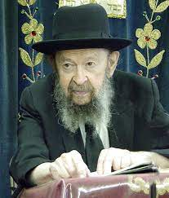

**QUESTION: What is a practical lesson that we could take out of Chanukah?**

**ANSWER:** I’ll tell you one important lesson. We say to Hashem about our forefathers who fought the Yevanim: דנת את דינם רבת את ריבם – “You, Hashem, judged their quarrels; You fought their fight.” Now, there’s a question here. Because it wasn’t their quarrel. It wasn’t the quarrel of the Am Yisroel. It was Your quarrel, Hashem. Because, after all, the Greeks weren’t interested in killing Jews. They wanted the Jews to stop keeping the Torah, that’s all.

If the Am Yisroel would be willing to behave like the Greeks, they wouldn’t bother them. So why was the Am Yisroel fighting? They weren’t fighting for their safety; they were fighting for Hashem’s word. It was for k’vod shamayim, for the honor of Hashem, that they fought. So, it wasn’t רבת את ריבם. It was רבת את ריבך – Hashem, You fought Your own fight! You fought Your quarrel!

**Hashem Fought Their Fight**

But no, we don’t say that. We say רבת את ריבם – You, Hashem, fought their fight! Because our forefathers had fulfilled what we say עשה רצונו כרצונך – Make the will of Hashem your will (Avos 2:4). What Hashem wanted, that’s what they wanted! They weren’t merely fighting for what Hashem wanted. What Hashem wanted became their ratzon, their own will.

That’s a tremendous achievement – to feel that we are keeping the Torah because the will of Hashem is our will. Not only that we’re  doing Hashem’s will, but it’s our will! כי הם חיינו — The Torah is our lifeblood. It’s more than our lives. And we’ll give our lives for the Torah. So, we see that even though they were fighting for k’vod shamayim, but they were fighting for their ratzon at the same time. 

**By the Hands of the Holy Kohanim**

And that’s why it’s so important, when you see that it was not only רבים ביד מעטים, but it was רשעים ביד צדיקים.

That’s important! It was a kiddush Hashem that the tzadikim won out. It was great kiddush Hashem! It says עשית שם גדול בעולמך. When tzadikim fight the fight of Hashem, when they’re willing to give up their lives for Hashem, that’s making the name of Hashem great in this world.

We say על ידי כהניך הקדושים. The miracle came by the hands of the holy Kohanim.  The  Kohanim! Kohanim should fight?! Kohanim are ovdei Hashem; they have no business with fighting. But these Kohanim went out with חרב וחנית, the sword and the shield, and they fought because they were fighting for Hashem’s honor. And therefore, Hashem says, “That’s a kiddush Hashem.”

**A Testimony to the Whole World**

And that’s why the Chanukah lights are עדות לכל באי עולם שהשכינה שורה בישראל, a testimony to the whole world that Hashem dwells amongst the Jewish people. Because we are the nation that lives for Hashem, we live for the Shechina. Our entire purpose is only k’vod shamayim, glorifying the name of Hashem.

And that’s the greatness of Chanukah. It teaches that our nation is dedicated to k’vod shamayim more than to anything else that we would desire to do; even more than our own lives. We live only for Hashem.

*Reprinted from the December 27, 2019 email of Toras Avigdor (Tape #E-170 – December 1998)*

**The Obligation to**

**Illuminate the World**

**From a Letter from the Lubavitcher Rebbe**

**Rabbi Menachem Mendel Schneerson, Zt”l**

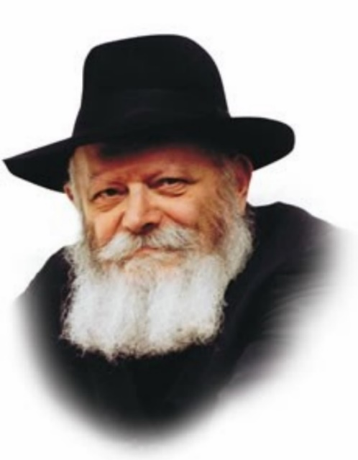

By the Grace of G‑d  
On the eve of Chanukah, 5741 [1980]  
Brooklyn, N.Y.

To all Participants in the Public Lighting of the Chanukah Menorah  
in the U.S.A.

Greeting and Blessing!

[Chanukah](https://www.chabad.org/holidays/chanukah/default_cdo/jewish/Chanukah-Hanukkah.htm), the Festival of Lights, recalls the victory—more than 2100 years ago—of a militarily weak but spiritually strong Jewish people over the mighty forces of a ruthless enemy that had overrun the Holy Land and threatened to engulf the land and its people in darkness.

The miraculous victory—culminating with the rededication of the Sanctuary in Jerusalem and the rekindling of the Menorah which had been desecrated and extinguished by the enemy—has been celebrated annually ever since during these eight days of Chanukah, especially by lighting the [Chanukah Menorah](https://www.chabad.org/library/article_cdo/aid/609661/jewish/The-Menorah.htm), also as a symbol and message of the triumph of freedom over oppression, of spirit over matter, of light over darkness.

**How to Chase Away the Darkness**

It is a timely and reassuring message, for the forces of darkness are ever present. Moreover, the danger does not come exclusively from outside; it often lurks close to home, in the form of insidious erosion of time-honored values and principles that are at the foundation of any decent human society. Needless to say, darkness is not chased away by brooms and sticks, but by illumination. Our Sages said, “A little light expels a lot of darkness.”

The Chanukah Lights remind us in a most obvious way that illumination begins at home, within oneself and one’s family, by increasing and intensifying the light of the Torah and Mitzvos in the everyday experience, even as the Chanukah Lights are kindled in growing numbers from day to day. But though it begins at home, it does not stop there. Such is the nature of light that when one kindles a light for one’s own benefit, it benefits also all who are in the vicinity. Indeed, the Chanukah Lights are expressly meant to illuminate the “outside,” symbolically alluding to the duty to bring light also to those who, for one reason or another, still walk in darkness.

**Promoting all the Forces of Light Both at Home and Abroad**

What is true of the individual is true of a nation, especially this great United States, united under [G‑d](https://www.chabad.org/library/article_cdo/aid/433240/jewish/God.htm), and generously blessed by G‑d with material as well as spiritual riches. It is surely the duty and privilege of this Nation to promote all the forces of light both at home and abroad, and in a steadily growing measure.

Let us pray that the message of the Chanukah Lights will illuminate the everyday life of everyone personally, and of the society at large, for a brighter life in every respect, both materially and spiritually.

With esteem and blessing in the spirit of Chanukah,

[Signed] M. Schneerson

*Reprinted from the Rebbe.org website in partnership with JEM (the Jewish Educational Movement).*

**Rav Shteinman’s Insight into**

**The Words of Al HaNissim**

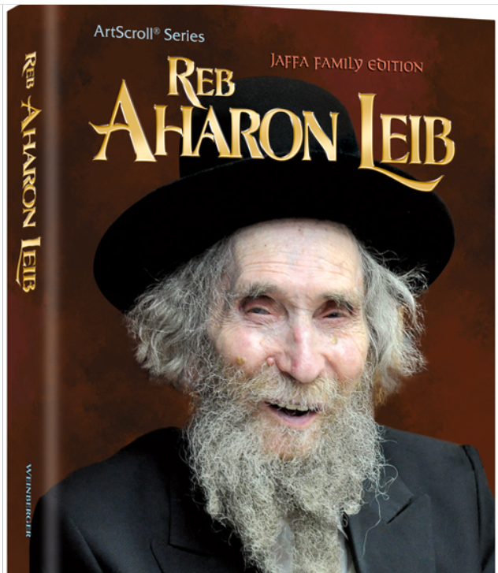

We say in Al HaNissim, “For the miracles, and for the salvation, and for the mighty deeds, and for the victories, and for the wars which You have performed for our forefathers in those days, at this time.”

Rav Aharon Yehuda Leib Shteinman, zt”l, writes: In the introductory paragraph to Al HaNissim, we praise Hashem for five things. Four of them are readily understandable. (1) One must give praise when he witnesses miracles, even if he does not see salvation as a result. (2) One must give praise for the actual salvation. (3) One must give praise whenever he witnesses Hashem’s mighty deeds, as we do when we see lightning or hear thunder, and (4) one must give praise for the victories that Hashem orchestrates.

However, why do we give praise for the wars? Rav Shteinman explains that we are obligated to praise Hashem for the fact that the Chashmona’im even had the courage to wage war.

After all, any rational person could see that they were sure to lose the battle! Also, we praise Hashem for giving them the strength to fight. (Rav Shteinman notes that based on this explanation, the phrase ‘V’Al HaMilchamos’, ‘For the wars’, should not be recited on Purim. It was not a miracle that the Jewish People went to war in the days of Mordechai and Esther. If they hadn’t gone to battle, they would have been killed.

In contrast, the Chashmona’im went to war for a spiritual cause. Indeed, Rav Shteinman notes, some editions of the Rambam’s Siddur omit the words ‘V’Al HaMilchamos’ on Purim.) Rav Shteinman continues to explain that we also learn from here that one should not just praise Hashem in a general way. Rather, one should praise Hashem for each and every aspect of a miracle that occurs.

**Not Easy to Attain Such a Level of Gratitude**

That would explain why the next paragraph, which begins with ‘Bimei Mattisyahu’, uses so many different phrases to describe the same events, such as “You fought their fight, You judged their judgment, You avenged their vengeance,” and so on. Rav Shteinman acknowledges that it is not easy to attain a level on which one can express his gratitude to such a degree.

However, this is not a form of Divine service reserved for Chanukah. Rather, we have the opportunity when we say ‘Modim’ three or more times every day to reflect on the deep debt of gratitude that we owe Hashem for our everyday life. This, in turn, will train us to reflect on the details of bigger miracles as well! (Yimalei Pi Sehilasecha, Iyunim B’Tefilah p.234)

*Reprinted from the Chanukah 5781 email of Rabbi Yehuda Winzelberg’s Torah U’Tefiah.*

**When Oil is not Oil**



Chanuka, a festival renowned for its connection to oil, is the perfect time to ponder the essence of that greasy liquid which is the ruination of dieters and health- conscious consumers alike.

When considering Chanuka's slippery quality, we are not merely referring to potato pancakes fried in oil nor jelly donuts similarly prepared. But in order to truly appreciate the slick nature of the festival of lights, we must contrast it with other Jewish holidays.

An important part of most Jewish holidays is the holiday meal, a time when it is truly a mitzva to eat and drink. Chanuka, however, is primarily celebrated by saying special prayers and lighting the Chanuka menora. These activities are how we commemorate the miraculous victory of the small Jewish army overpowering the mighty Greek war machine and the jar of pure oil miraculously keeping the Temple candleabra lit for eight days.

Our Chanuka observances are more "spiritual" because the victory of Chanuka was a victory of the spirit. The Greeks wanted to make the Jewish people forget the Torah and transgress the Divine commandments. Thus, it is fitting to celebrate the holiday with less emphasis on mundane food and more emphasis on spiritual activities.

The difference between other holidays and Chanuka can be better understood by comparing water, bread, and wine, foods served at holiday meals with oil, which is used for the Chanuka lights.

Water, bread, wine and oil are all metaphors for the Torah. There are, of course, differences between them.

Water and bread are the staples of our everyday existence. In contrast, wine is not a daily necessity, it is used to contribute an element of pleasure to our existence. Oil is not required for our day-to-day existence. It is never served as a food in its own right. Rather, it is used in minute quantities to add flavor to other foods. Thus, it too, is associated with the quality of pleasure.

Bread and water are metaphors for the revealed dimensions of the Torah, the concepts of Torah which are necessary in order to know how to observe the mitzvot properly. Like bread and water, this knowledge is necessary for our very existence.

In contrast, wine and oil are metaphors for the inner dimensions of Torah (such as Chasidism), for like these two substances, the study of the inner dimension of the Torah adds pleasure and vitality to our observance of the Torah and mitzvot.

Taking this a step further, there is a difference between oil and wine. Wine is drunk as a beverage in its own right, while oil it not. In regard to the symbolic meaning of the two, wine refers to those dimensions of the Torah's secrets which are close to revelation and can be perceived by a sensitive eye. In contrast, oil refers to the deepest secrets of the Torah, those that transcend revelation. And Chanuka is associated with these deepest levels of Torah.

Chanuka is the perfect time to slowly begin adding the "oil" of Torah study to our daily diets of Jewish living.

*Reprinted from the 5758/1997 Mikeitz edition of L’Chaim (Issue #449), a publication of the Lubavitch Youth Organization in Brooklyn, NY.*